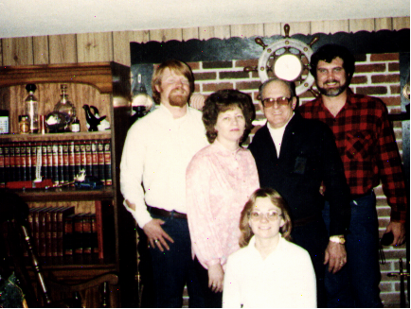
Dillwyn, Va Derrick, Mary, Debbie, Jessie, Paul
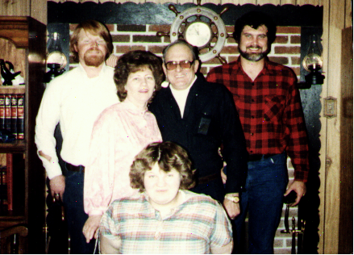
Dillwyn, Va Derrick, Mary, Lisa, Jessie, Paul
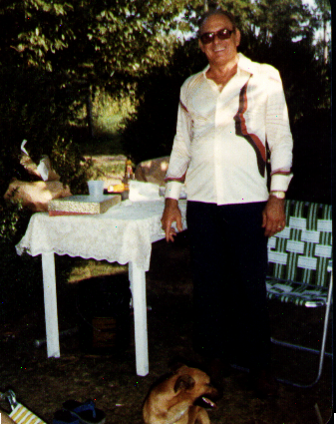
Dillwyn, Va Jessie, Rocky
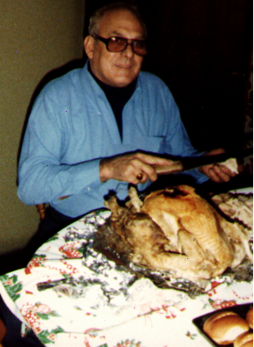
Dillwyn, Va Jessie, Turkey
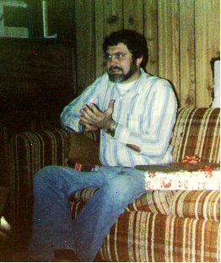
Dillwyn, Va Paul
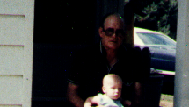
Dillwyn, Va Jessie, Russell
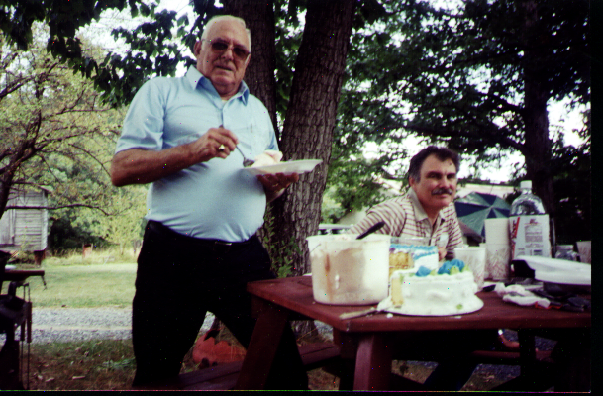
Jessie and Paul Dillwyn, VA

