
Sky Line Drive, VA Paul
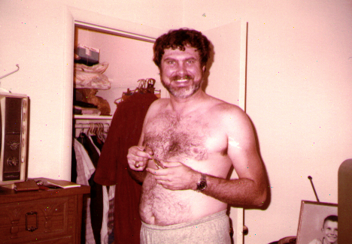
Richmond, VA Goolsby Apt Paul
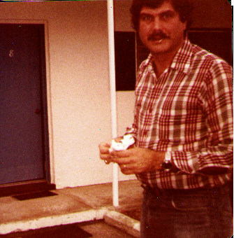
Richmond, VA Goolsby Apt Paul
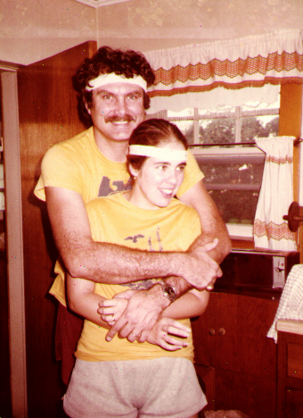
Fair Lawn, NJ Paul and Dorothy
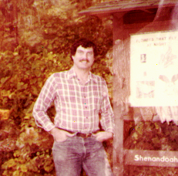
Sky Line Drive, VA Paul
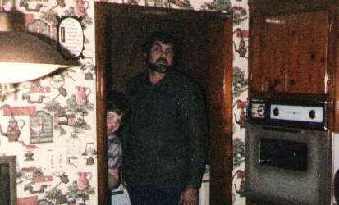
Dillwyn, VA Paul

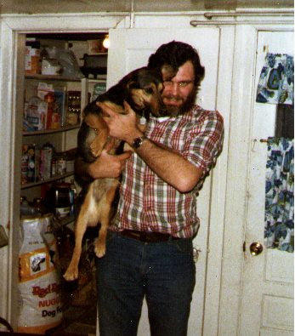
Powhatan, VA Paul
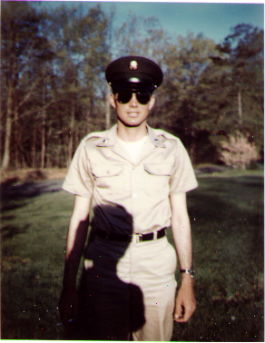
Dillwyn, VA Paul
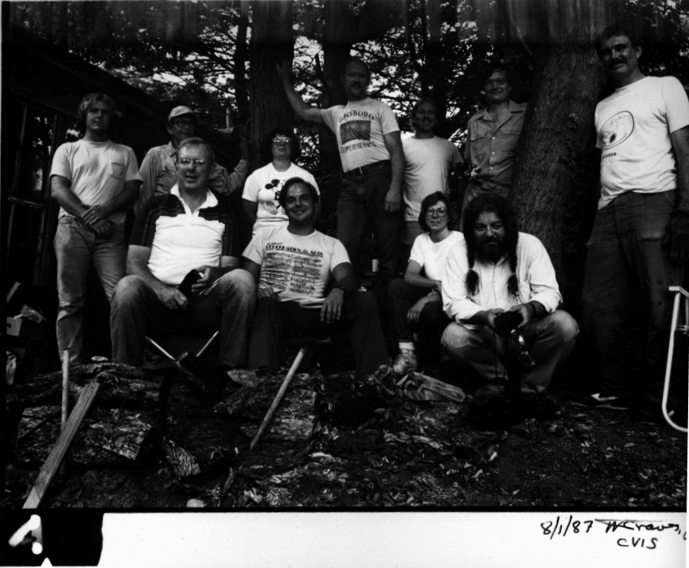
Paul Rock Knapping Lynchburg, VA

