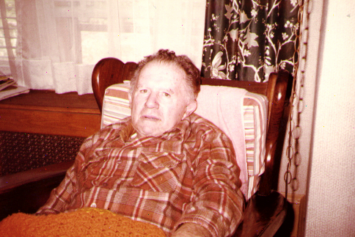
Sal in Fairkawn, NJ

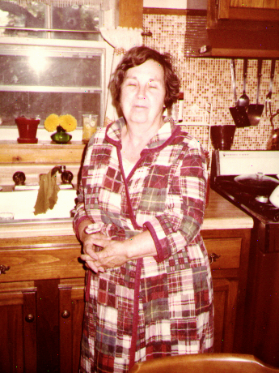
Delores in Fairkawn, NJ

